Announcement of / Invitation for the

Csizmadia Ferenc Memorial Trophy
Danubia Series 2024-25 in Short Track Speed Skating


Debrecen, Hungary
January 31 – February 2, 2025


ANNOUNCEMENT
- Organizer of the competition: Hungarian National Skating Federation (HNSF)
The HNSF has the honour of inviting you to take part in the Csizmadia Memorial Trophy Danubia Series 2024-25 in Short Track Speed Skating supported by the ISU Development. The HNSF reserves the right to change the date, location, and program of the competition.
The competitors acknowledge that upon cancellation of the competition they do not have the right to claim back the already paid entry fee as the HNSF had various costs concerning the competition.
HNSF Competition Director Competitors’ Steward
VÁRADI Orsolya comp.steward@hunskate.hu
3-5 Istvánmezei street, Budapest, H-1146
Phone: +36 1 252 2369
E-mail: info@hunskate.hu
- Location: Debrecen Ice Hall – 33 Derék utca, Debrecen, H-4031
The competition will be held in the covered Debrecen Ice Hall with an indoor ice rink measuring 30x60 metres and a traditional padding system. The compass of the track is 111.12 metres with curves of 8 metres as per the ISU Rules. There will be seven (7) tracks with a displacement of 0,7 metre each, while the finish line for all distances is the same and only the starting place of distances 500 metres and 1500 metres will be changed.
- Date: January 31 – February 2, 2025
- Guiding rules:
The competition will be carried out according to the International Skating Union’s (ISU) General Regulations 2024 and the relevant Communications.
- Participation:
- only registered competitors of ISU Members are allowed to participate, clubs can only make entries through the respective members
- only those competitors who have submitted their entries and paid the entry fee by the given deadline are allowed to participate
- Please indicate your intention of participation as soon as possible in order to enable us to prepare the competition as well as possible.
- Technicalities:
- categories and age groups for the Danubia Series
Junior C | born between | 01.07.2008 | - | 30.06.2010
Junior D | born between | 01.07.2010 | - | 30.06.2012
- categories and age groups out of the Danubia Series scoring
Junior E | born between | 01.07.2012 | - | 30.06.2014
Junior F | born between | 01.07.2014 | - | 30.06.2016

Competitors in categories out of the Danubia Series (Junior E, F) can be entered in limited numbers and the OC reserves the right to close registration before the deadline, should the submitted entries reach the limit. The limitation will be carried out in accordance with the date of submitted entries (on a first come, first serve basis).

- distances
INDIVIDUAL (all final system):
Junior C | 1500 m | 500 m | 1000 m
Junior D | 1000 m | 500 m | 777 m

Junior E | 777 m | 333 m | 500 m
Junior F | 500 m | 222 m | 333 m

RELAY:

Women | 2000 m | Junior C+D | 3 skaters
Men | 2000 m | Junior C+D | 3 skaters
- relay entries: each ISU Member has the right to enter more than one team per category in Junior (limitations may apply depending on the submitted entries). The Members have to rank their relay teams (the fastest team to be ranked 1). Relay members must have participated in the individual events.
- Conditions of Contest
- the individual and relay conditions of contest will be determined after the final entry deadline, once the number of competitors has been finalized. The individual competition we prefer the ALL-Final system in the design of the program.
- the start procedure will be conducted using the traditional system for Junior C-D-E-F categories
- Entries: by submitting an entry the competitor clearly agrees to all terms set in this Announcement
Please note that entries can only be accepted if a skater is entered into the correct age category or the next higher category according to their date of birth. However, if a skater is entered into the next higher age category, they should compete in that category in case of all Danubia Series events.
- by submitting an entry, Hungarian competitors in categories Junior C are automatically entered into the ‘Magyar Kupa sorozat’ (Hungarian Cup only for Hungarian citizens cf. page 7)
- entries can only be made electronically via the www.shorttracklive.info website and must clearly state:
  - the title of the competition
  - the name of the Club and ISU Member making the entry
  - the number of athletes in each category
  - the number of coaches and team leaders
  - the first (given) name and surname, and date of birth of the competitor(s)
  - the date and time of arrival and departure of the competitor(s) and those accompanying them
  - the financial statement of the respective Club/ISU Member that all occurring costs will be covered by them
- the Preliminary Entries should be submitted by January 16, 2025 at the latest
- the Final Entries should be communicated to the OC until January 22, 2025 at the latest
If you have further questions on this subject (username, password etc.), please do not hesitate to contact Mr. Hermann Filipic, e-mail: hermann@filipic1.at
- Payment:
- the entry fee is 50,- EUR/person,
- the entry fee must be paid via bank transfer until January 26, 2025 at the latest.
bank details: bank account holder: MOKSZ
name of the bank: MBH Bank Nyrt.
bank swift code: MKKBHUHB
IBAN account number: HU94 10300002-50100124-21004884
description: CSIZMADIA_ISU Member_Skaters’ surnames
(e.g. CSIZMADIA_HUN_Smith, Murphy etc.)
- late entry fee is 60,- EUR/person + 4% bank fee and can only be paid via bank card before the Technical Meeting
Please note that helmet covers and transponders will only be handed over at the Technical Meeting if payment is fulfilled!
- the deposit for helmet covers is 50,- EUR/team (has to be paid in cash at the Technical Meeting)
- cancellation is only accepted by the HNSF in case of an injury or illness – strictly supported by medical certificate, in which case the amount of entry fee will be refunded
- Equipment: only that equipment which are in accordance with the ISU Rules can be used in the competitions; this will be checked in the Heat Box before the competitors enter the ice.
- compulsory rounding of the ending of the blades
- helmet
- cut proof gloves
- neck protectors (the built-in neck protectors are also suitable)
- cut-proof skinsuit for competitors in Junior C-D categories

- Awards:
The first three placed competitors of each distance and category receive a medal immediately after the respective final on ice, while the first three placed competitors of the individual all-round competition, and the first three placed relay teams in each category will be awarded with medals respectively at the end of the competition.
The best placed Hungarian competitors in Junior C (1 woman and 1 man) will win the CSIZMADIA TROPHY in memory of Ferenc Csizmadia.
- Accommodation: all meals and lodging expenses are to be paid by the participating members. The OC recommends hotels nearby the Debrecen Ice Hall as listed below but does not take any responsibility for booking accommodation for the participants. Reservations should be made directly via the chosen hotel and in advance.
Gulyás Pál Hostel: e-mail gulyasszallas@gmail.com,
website https://www.gulyasp-koll.edu.hu/szallas
Belga Boutique Guest House: e-mail iroda.belgaetterem@gmail.com,
website https://belgapanzio.hu/belga-boutique-hotel-english-version/
M37 Apartments: info@m37.hu,
website https://www.m37apartman.hu/en/
Hotel Debrecen: e-mail info@hoteldebrecen.com
website https://hoteldebrecen.com/en/home/
Centrum Hotel: e-mail info@centrumhotel.hu,
website https://centrumhotel.hu/en/home/
Malom Hotel: e-mail malomhotel@malomhoteldebrecen.hu
website https://malomhotel.hu/en
Inter Hotel: e-mail info@interhotel.hu,
website https://interhotel.hu/en/
- Lunch: at the ice rink
It is possible to order warm lunch beforehand at the ice rink for all competition days. The price is 12 Euros / person / 1-course meal.
Orders should be made through the Organizing Committee via e-mail: boroka.kovacs@hunskate.hu until January 17.
- Citizenship / Residence Requirements and Clearance Procedure
In accordance with Rule 109 of ISU Regulations and the current ISU communication, all skaters who do not have the nationality of the Member by which they have been entered or who, although having such nationality, have in the past represented another Member, must produce an ISU Clearance Certificate.
- Results and live stream
All results of the competition series will be published on the website as follows: www.shorttracklive.info
The competition can be followed live on the hunskate.tv/hunskate-tv platform.
- Miscellaneous:
- each competitor participates in the competition at his/her own risk and insurance; the ISU, the HNSF and the OC do not take responsibility for or liability with respect to any injury or property damage incurred in connection with the competition
- by entering all participants accept and agree that they might be subject to recording (audio and picture), and might appear in the media content created about the competition
- by entering all participants accept that personal data are collected by the Organizing Committee (OC) and such data are stored and used by the OC, and when necessary, third parties, for the purposes only of, and to the extent necessary only in relation to facilitate their participation in the competition; personal data may include but will not be limited to full legal name as per national identity documents, address, date of birth, nationality, sex
- the OC provides medical service (ambulance) during the competition

- Preliminary program / schedule: it is subject to change based on the final entries (!)
Day | Event | Time
January 31 (Friday) | Technical Meeting | 08:15 the starting time can change based on the final entries
 | warm up and competitions | 09:00-20:00
February 01 (Saturday) | warm up | 08:00-08.45
 | competitions | 09:00-20:00
February 02 (Sunday) | warm up | 08.00-08.45
 | competitions | 09:00-15.00
 | Awarding Ceremony | 15.10

Budapest, December 18, 2024

Mr. KÓSA Lajos Ms. VÁRADI Orsolya
President Director General

Short Track Magyar Kupa
2024/2025-ös versenyszezon
A Magyar Kupa sorozatban három hazai verseny szerepel: a Mikulás Kupa, a Jász Kupa és a Tisza Kupa. A sorozatban csak olyan magyar versenyző kerülhet értékelésre, aki legalább két eseményen részt vesz. Tekintettel arra, hogy a Mikulás Kupán a B és C kategóriájú versenyzők nem tudtak részt venni a Magyar Kupa rendszerében, a Csizmadia Trophy-n ezt pótolhatják, azaz Junior C kategóriában a Csizmadia Trophy eredménye számít a Magyar Kupa sorozat értékelésébe. Az életkori kategóriák a Csizmadia Trophy-n: C, nemenként külön-külön. A versenyzők csak a saját kategóriájukban elért eredmények alapján szerezhetnek magyar kupa pontokat. Alapvetően a G korcsoport versenyzőit az F kategória részeként értelmezzük. Amennyiben a G korcsoport külön versenyez, az elért helyezéseiket az F kategória végére soroljuk, a hosszú-, rövid- és középtávokat figyelembe véve. Az egyéb korosztályokban azokon a versenyeken, ahol összevontan versenyeznek, a kategóriákra bontott eredmények a mérvadóak. A váltók A-B kategóriában négy fővel 3000 méteren, C-D és E-F kategóriákban három fővel 2000 méteren versenyeznek, szintén nemenként. Egyesületenként egy váltócsapat kerül értékelésre a Magyar Kupában. A vegyes váltóversenyek nem kerülnek be a Magyar Kupa pont értékelésébe. Pontszerzés szempontjából kategóriánkként csak azok a versenyek vehetők figyelembe, ahol az adott egyéni vagy váltó kategóriában legalább két versenyző vagy váltó részt vesz. Amennyiben a különböző életkori kategóriákban a résztvevők létszáma nem éri el a minimum kritériumot egy versenyen sem, a Magyar Kupa összesített végeredménye nem értelmezhető, nem hirdetünk végeredményt.
Egyéni pontozás:
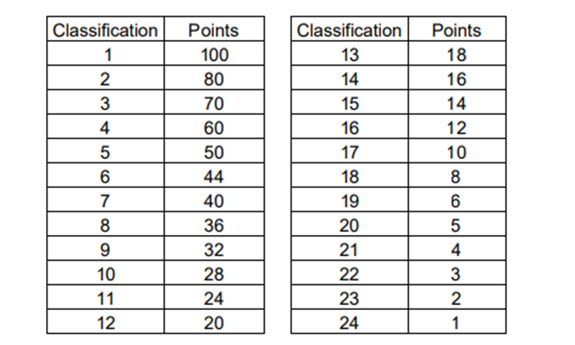
Az egyéni kategóriákban három versenyen lesz értékelés, így egy versenyző ideális esetben kilenc alkalommal érhet el helyezést. Az eredményeket a világkupa pontozási rendszer pontjai alapján regisztráljuk. Az elért pontszámok közül maximum a legjobb hatot vesszük figyelembe, és ezek összege alapján alakul ki a Magyar Kupa összetett sorrendje. A távok között nincs prioritás. Pontazonosság esetén a jobb helyezések döntenek, ha ez is azonos, akkor a legjobb hosszútávon elért idő eredménye rangsorol.
Váltó pontozás:
Az egyéni versenyekhez hasonlóan az új világkupa pontozási rendszer alapján egyesületenként és korcsoportonként egy váltó figyelembevételével a három versenyből a két legjobb helyezés számít. Ha egy egyesület több váltót is indít, akkor csak a legjobb helyezést elért csapatát vesszük figyelembe a pontszámításnál. Pontazonosság esetén a jobb helyezések, illetve ezek azonossága esetén a legjobb időeredmény alapján kerül sor a rangsorolásra. A váltók esetében az egyesületeket rangsoroljuk, a váltók eltérő összeállításától függetlenül, különböző klubokból összeállított váltók nem kerülnek értékelésre.
Eredményhirdetés:
A Magyar Kupa eredményhirdetésére az Utánpótlás bajnokságon kerül sor.
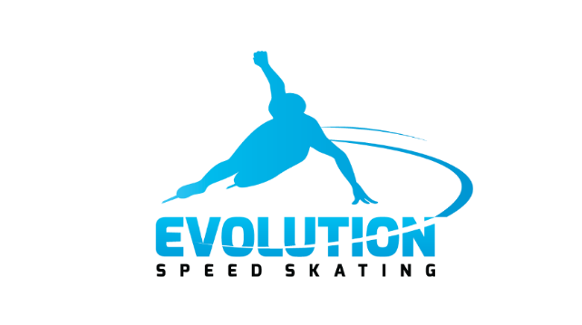
A Magyar Kupa versenyek együttműködő partnere az evolutionspeedskating.hu !

