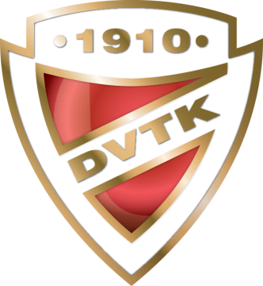

ENTRY FORM FOR SKATERS

18. DVTK-AVAS Cup

Interclub Figure Skating Competition

5-7 April 2024, MISKOLC-HUNGARY

Please, return this form not later than 12 March 2024
E-Mail: competition.dvtk@gmail.com

Men
Nr. Name (FAMILY NAME, Given name) Category Date of Birth (DD/MM/YY)
1.
2.
3.

Ladies
Nr. Name (FAMILY NAME, Given name) Category Date of Birth (DD/MM/YY)
1.
2.
3.
4.
5.
6.
7.
8.

ISU Member Federation:

Date, Signature:

