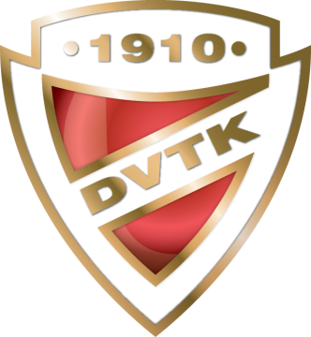
PLANNED PROGRAM CONTENT

15. DVTK-AVAS CUP

Interclub Senior, Junior, Novice, Youngsters, Recreational and Adult
23-25 April, 2021, MISKOLC-HUNGARY

Please, return this form not later than 10 April 2021
competition.dvtk@gmail.com

Club Name and Country:
Category:
Name of Competitor(s):

ELEMENTS IN ORDER OF SKATING

 | Elements SP | Elements FP
1
2
3
4
5
6
7
8
9
10

ISU Member Federation:

Date, Signature:

