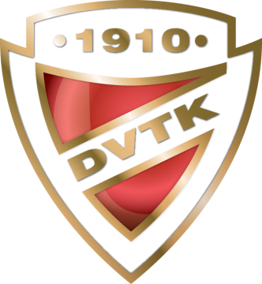

ENTRY FORM FOR SKATERS

15. DVTK-AVAS Cup

Interclub Senior, Junior, Novice, Youngsters, Recreational and Adult
Figure Skating Competition
23-25 April, 2021, MISKOLC-HUNGARY

Please, return this form not later than 15 March 2021
email: competition.dvtk@gmail.com

Men
Nr. Name (FAMILY NAME, Given name) Category Date of Birth (DD/MM/YY)
1.
2.
3.

Ladies
Nr. Name (FAMILY NAME, Given name) Category Date of Birth (DD/MM/YY)
1.
2.
3.
4.
6.
7.
8.
9.

ISU Member Federation:

Date, Signature:

